**MODEL 1**

|  |  |  |  |  |  |
| --- | --- | --- | --- | --- | --- |
|  | **F(4,11998)** | **Prob > P** | **R-Squared** | **Adj-R2** |  |
|  | 516.492 | 2.2e-16 | 0.147 | 0.147 |  |
|  |  |  |  |  |  |
|  | **Estimate** | **Std. Error** | **t value** | **Pr(>|t|)** | **Std. Beta Coeff.** |
| (Intercept) | 112.082 | 2.29 | 48.948 | 2E-16 |  |
| last_evaluation | 53.998 | 2.542 | 21.24 | 2E-16 | 0.18654257 |
| number_project | 11.349 | 0.376 | 30.158 | 2E-16 | 0.27123093 |
| left | 6.297 | 1.164 | 5.409 | 6.5E-08 | 0.04816194 |
| Imp_timeSpend | 1.761 | 0.517 | 3.41 | 0.00065 | 0.03139965 |

**Variables Taken:**

**DV:** Average_Monthly_Hours;

**IV:** Last_Evaluation, Number_Projects, Left, Imp_TimeSpent

**Model significance:** F=516.492, p<0.05 indicate that overall regression model is significant

**Significance of individual predictors:**

* The Table indicates that all the IV’s have a significant effect on the DV. Hence Average_Monthly_Hours is dependent on all IV’s
* last_evaluation and number_project are the most significant predictors of Average_Monthly_Hours followed by left and Imp_timeSpend
* All IV’s are affecting the DV positively.

**Model Fit:**

**Adjusted R2**= 14.7%

**Standard Error** = 45.01 on 11998 degrees of freedom

The model is able to explain 14.7% variation in Average_Monthly_Hours.

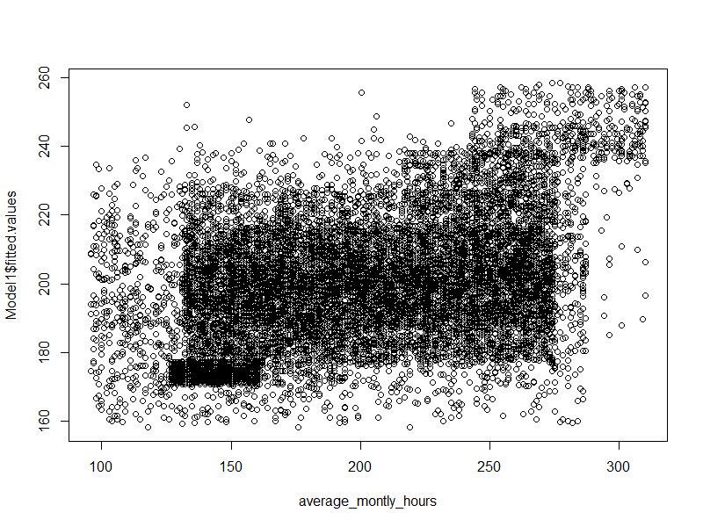

**MODEL 2**

|  |  |  |  |  |  |
| --- | --- | --- | --- | --- | --- |
|  | **F(3,11999)** | **Prob > P** | **R-Squared** | **Adj-R2** |  |
|  | 684.174 | 2.2e-16 | 0.1461 | 0.1459 |  |
|  |  |  |  |  |  |
|  | **Estimate** | **Std. Error** | **t value** | **Pr(>|t|)** | **Std. Beta Coeff.** |
| (Intercept) | 115.79 | 2.016 | 57.436 | 2E-16 |  |
| last_evaluation | 54.623 | 2.537 | 21.532 | 2E-16 | 0.18870057 |
| number_project | 11.638 | 0.367 | 31.722 | 2E-16 | 0.27812347 |
| Left | 7.565 | 1.104 | 6.855 | 4.9E-09 | 0.05786218 |

(after removing the relatively insignificant predictor i.e. Imp_timeSpend from Model 1)

**Variables Taken:**

**DV:** Average_Monthly_Hours;

**IV:** Last_Evaluation, Number_Projects, Left

**Model significance:** F= 684.2, p<0.05 indicate that overall regression model is significant

**Significance of individual predictors:**

* The Table indicates that all the IV’s have a significant effect on the DV. Hence Average_Monthly_Hours is dependent on all IV’s
* last_evaluation and number_project are the most significant predictors of Average_Monthly_Hours followed by left.
* All IV’s are affecting the DV positively.

**Model fit**

**Adjusted R2** =14.59%

**Standard Error** = 45.03 on 11999 degrees of freedom

Hence, Model 2 is worse off than Model 1 as it is able to explain a lesser degree of the total variation in the DV

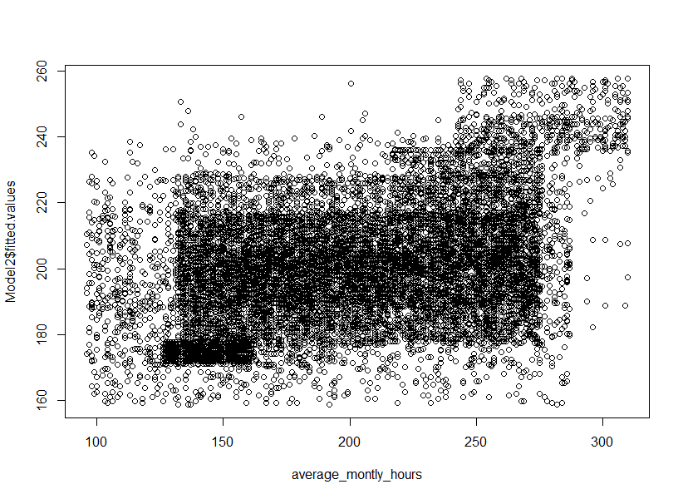

**MODEL 3**

|  |  |  |  |  |  |
| --- | --- | --- | --- | --- | --- |
|  | **F(4,11998)** | **Prob > P** | **R-Squared** | **Adj-R2** |  |
|  | 513.69 | 2.2e-16 | 0.1462 | 0.1459 |  |
|  |  |  |  |  |  |
|  | **Estimate** | **Std. Error** | **t value** | **Pr(>|t|)** | **Std. Beta Coeff.** |
| (Intercept) | 118.208 | 2.628 | 44.977 | 2E-16 |  |
| last_evaluation | 54.508 | 2.538 | 21.477 | 2E-16 | 0.18830178 |
| number_project | 11.546 | 0.372 | 31.005 | 2E-16 | 0.27592955 |
| Left | 7.152 | 1.141 | 6.271 | 3.71E-10 | 0.05470242 |
| Inv_TimeSpent | -5.715 | 3.986 | -1.434 | 0.152 | -0.01273642 |

(after adding Inv_TimeSpent from Model 2)

**Variables Taken:**

**DV:** Average_Monthly_Hours;

**IV:** Last_Evaluation, Number_Projects, Left, Inv_TimeSpent

**Model significance:** F= 513.7, p<0.05 indicate that overall regression model is significant

**Significance of individual predictors:**

* The Table indicates that all the IV’s have a significant effect on the DV except for Inv_TimeSpent. Hence Average_Monthly_Hours is dependent on all IV’s except for Inv_TimeSpent
* last_evaluation and number_project are the most significant predictors of Average_Monthly_Hours followed by left.
* All IV’s are influencing the DV positively except for Inv_TimeSpent which is negatively influencing it.

**Model fit**

**Adjusted R2** = 14.59%

**Standard Error** = 45.03 on 11998 degrees of freedom

Hence, Model 3 is still worse off than the original Model 1 in being able to explain the degree of variation in the DV. But its results are equivalent to Model 2.

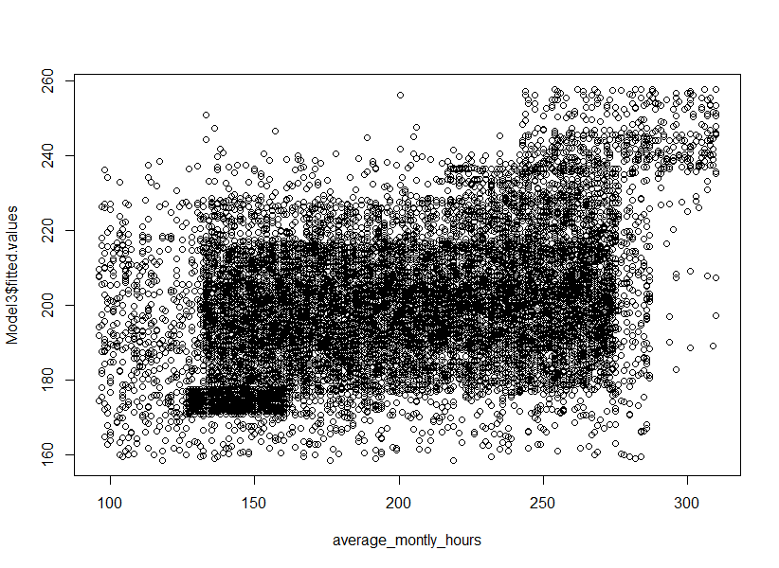

**MODEL 4 (REDACTED)**

|  |  |  |  |  |  |
| --- | --- | --- | --- | --- | --- |
|  | **F(4,11174)** | **Prob > P** | **R-Squared** | **Adj-R2** |  |
|  | 507.462 | 2.2e-16 | 0.1537 | 0.1534 |  |
|  |  |  |  |  |  |
|  | **Estimate** | **Std. Error** | **t value** | **Pr(>|t|)** | **Std. Beta Coeff.** |
| (Intercept) | 110.873 | 2.317 | 47.86 | 2E-16 |  |
| last_evaluation2 | 53.226 | 2.637 | 20.183 | 2E-16 | 0.18367906 |
| number_project2 | 11.804 | 0.389 | 30.353 | 2E-16 | 0.28330932 |
| left2 | 5.224 | 1.196 | 4.367 | 1.3E-05 | 0.04033066 |
| time_spend_company2 | 1.792 | 0.517 | 3.465 | 0.00053 | 0.03319568 |

**Variables Taken:**

**DV:** Average_Monthly_Hours;

**IV:** Last_Evaluation, Number_Projects, Left, TimeSpent

**Model significance:** F=507.462, p<0.05 indicate that overall regression model is significant

**Significance of individual predictors:**

* The Table indicates that all the IV’s have a significant effect on the DV. Hence Price Average_Monthly_Hours is dependent on all the variables.
* last_evaluation2 and number_project2 are the most significant predictors of Average_Monthly_Hours followed by left2 and time_spend_company 2.
* All the IV’s positively influence the DV

**Model Fit:**

**Adjusted R2** =15.34%

**Standard Error** = 44.68 on 11174 degrees of freedom

The model is able to explain 15.34% variation in Average_Monthly_Hours.

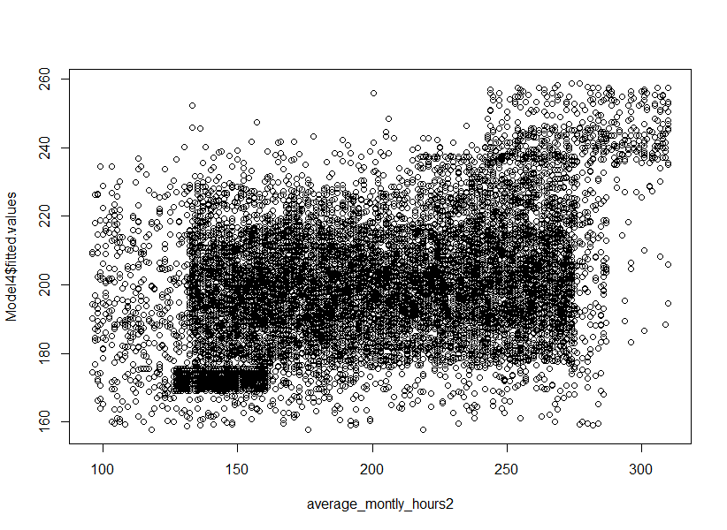

**MODEL 5**

|  |  |  |  |  |  |
| --- | --- | --- | --- | --- | --- |
|  | **F(3,11175)** | **Prob > P** | **R-Squared** | **Adj-R2** |  |
|  | 671.953 | 2.2e-16 | 0.1528 | 0.1526 |  |
|  |  |  |  |  |  |
|  | **Estimate** | **Std. Error** | **t value** | **Pr(>|t|)** | **Std. Beta Coeff.** |
| (Intercept) | 114.472 | 2.072 | 55.254 | 2E-16 |  |
| last_evaluation2 | 53.979 | 2.63 | 20.528 | 2E-16 | 0.18627508 |
| number_project2 | 12.121 | 0.378 | 32.054 | 2E-16 | 0.29092314 |
| left2 | 6.606 | 1.128 | 5.855 | 4.90E-09 | 0.05100475 |

(after removing the relatively insignificant predictor i.e. time_spend_company2 from Model 4)

**Variables Taken:**

**DV:** Average_Monthly_Hours;

**IV:** Last_Evaluation, Number_Projects, Left

**Significance of individual predictors:**

* The Table indicates that all the IV’s have a significant effect on the DV. Thus, Average_Monthly_Hours is dependent on all IV’s .
* left2 is the most significant predictors of Average_Monthly_Hours followed by last_evaluation2 and number_project2.
* All IV’s are affecting the DV positively.

**Model fit**

**Adjusted R2** =15.26%

**Standard Error** = 44.7 on 11175 degrees of freedom

Hence, Model 5 is slightly worse off than Model 4 as it is able to explain a lesser degree of the total variation in the DV

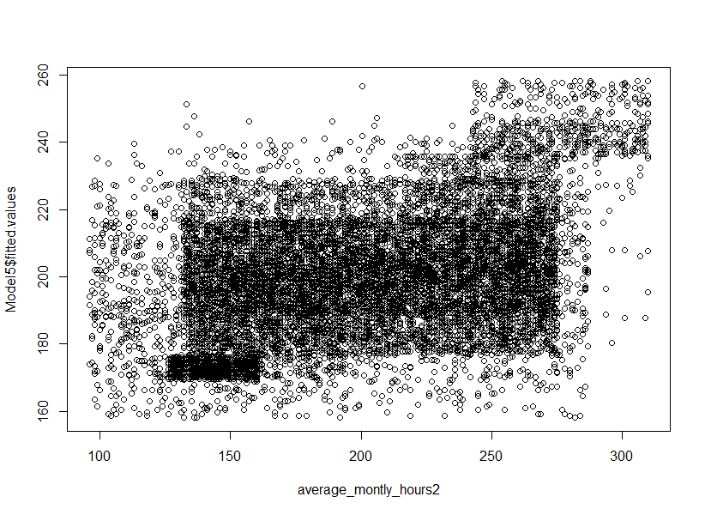

**MODEL 6**

|  |  |  |  |  |  |
| --- | --- | --- | --- | --- | --- |
|  | **F(4,11174)** | **Prob > P** | **R-Squared** | **Adj-R2** |  |
|  | 505.561 | 2.2e-16 | 0.1532 | 0.1529 |  |
|  |  |  |  |  |  |
|  | **Estimate** | **Std. Error** | **t value** | **Pr(>|t|)** | **Std. Beta Coeff.** |
| (Intercept) | 111.5 | 2.424 | 45.989 | 2.00E-16 |  |
| last_evaluation2 | 53.589 | 2.634 | 20.344 | 2.00E-16 | 0.18493226 |
| number_project2 | 11.93 | 0.387 | 30.85 | 2.00E-16 | 0.28632424 |
| left2 | 5.684 | 1.194 | 4.761 | 1.95E-06 | 0.0438863 |
| Log_TimeSpent2 | 8.701 | 3.69 | 2.358 | 0.0184 | 0.02235662 |

(after adding Log_TimeSpent2 from Model 5)

**Variables Taken:**

**DV:** Average_Monthly_Hours;

**IV:** Last_Evaluation, Number_Projects, Left, Log_TimeSpent

**Model fit**

**Adjusted R2** =15.29%

**Standard Error** = 44.69 on 11174 degrees of freedom

**Significance of individual predictors:**

* The Table indicates that all the IV’s have a significant effect on the DV. Thus, Average_Monthly_Hours is dependent on all IV’s .
* last_evaluation2 and number_project2 are the most significant predictors of Average_Monthly_Hours followed by left2 and Log_TimeSpent2.
* All IV’s are affecting the DV positively.

**Model fit**

**Adjusted R2** =15.29%

**Standard Error** = 44.69 on 11174 degrees of freedom

Hence, Model 6 is slightly better than Model 5 as it is able to explain a lesser degree of the total variation in the DV but is inferior to model 4 in it.

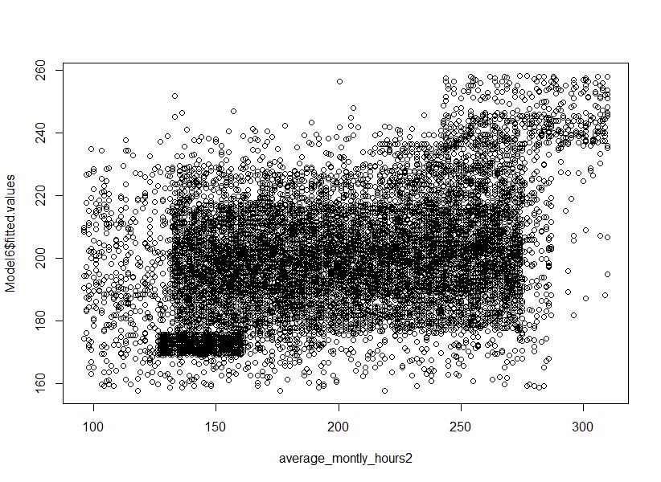

**MODEL 7**

|  |  |  |  |  |  |
| --- | --- | --- | --- | --- | --- |
|  | **F(4,11174)** | **Prob > P** | **R-Squared** | **Adj-R2** |  |
|  | 504.337 | 2.2e-16 | 0.1529 | 0.1526 |  |
|  |  |  |  |  |  |
|  | **Estimate** | **Std. Error** | **t value** | **Pr(>|t|)** | **Std. Beta Coeff.** |
| (Intercept) | 116.848 | 2.877 | 40.611 | 2.00E-16 |  |
| last_evaluation2 | 53.844 | 2.632 | 20.458 | 2.00E-16 | 0.18581242 |
| number_project2 | 12.039 | 0.384 | 31.325 | 2.00E-16 | 0.28895972 |
| left2 | 6.16 | 1.189 | 5.181 | 2.25E-07 | 0.04755837 |
| Inv_TimeSpent2 | -5.428 | 4.561 | -1.19 | 0.234 | -0.01113823 |

(After adding Log_TimeSpent2 from Model 5)

**Variables Taken:**

**DV:** Average_Monthly_Hours;

**IV:** Last_Evaluation, Number_Projects, Left, Inv_TimeSpent

**Significance of individual predictors:**

* The Table indicates that all the IV’s have a significant effect on the DV. Thus, Average_Monthly_Hours is dependent on all IV’s .
* last_evaluation2, number_project2 and left2 are the most significant predictors of Average_Monthly_Hours followed by Inv_TimeSpent2.
* last_evaluation2, number_project2 and left2 are affecting the DV positively where as Inv_TimeSpent2 is affecting the DV negatively.

**Model fit**

**Adjusted R2** =15.26%

**Standard Error** = 44.7 on 11174 degrees of freedom

Hence, Model 7 is slightly worse off than Model 6 as it is able to explain a lesser degree of the total variation in the DV. It is equivalent to model 5 and inferior to model 4.

